**1.**

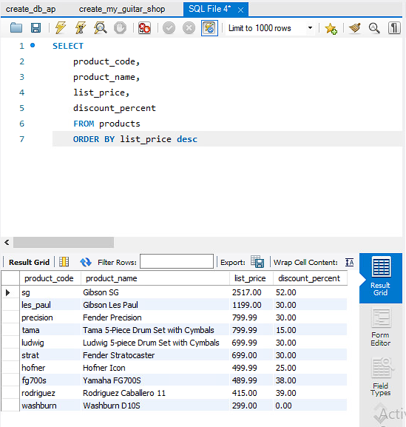

**2.**

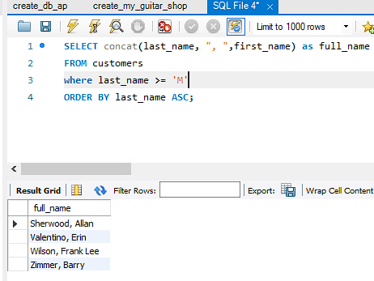

**3.**

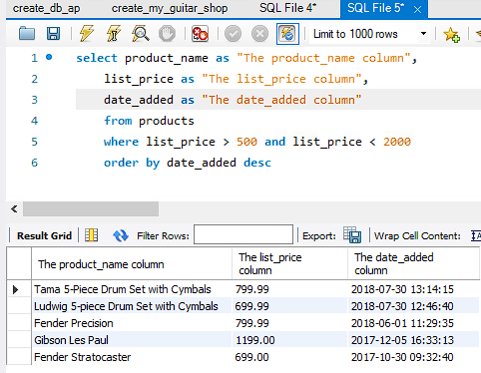

**4.** 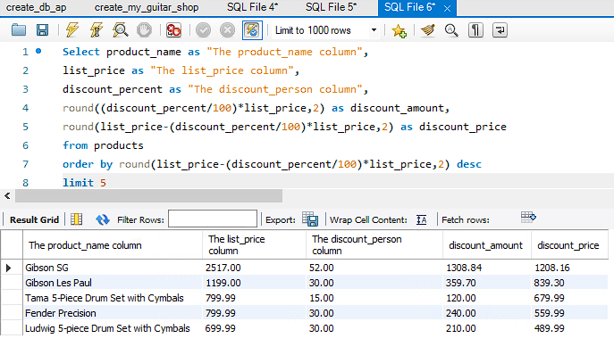

**Continue to next page**

**5.**

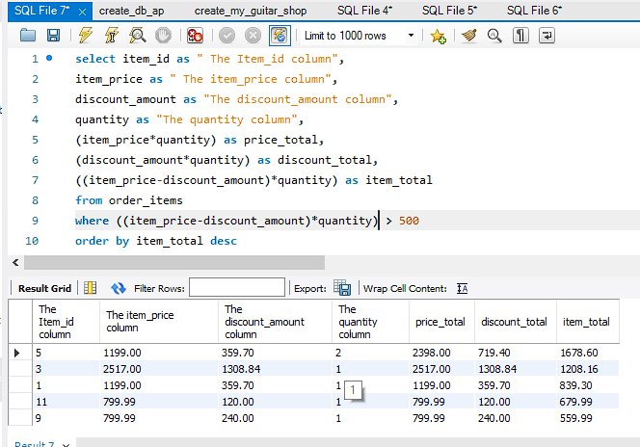

**6.**

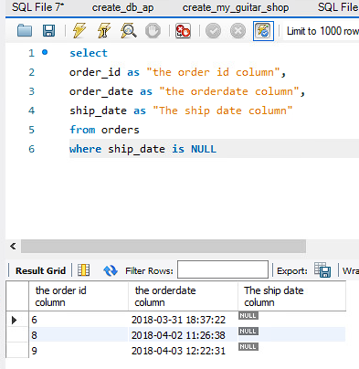

**7.Citation:** [**https://dev.mysql.com/doc/refman/8.0/en/date-and-time-functions.html**](https://dev.mysql.com/doc/refman/8.0/en/date-and-time-functions.html)

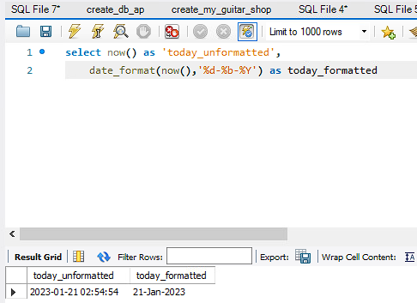

**8.**

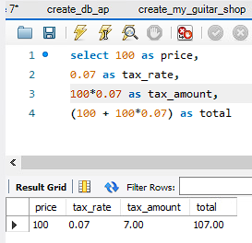

**Continue to next page**

**9.**

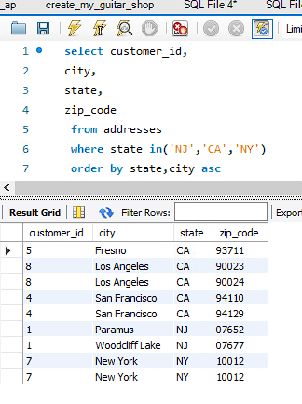

**10. citation:** [**https://www.w3schools.com/sql/func_mysql_substring.asp**](https://www.w3schools.com/sql/func_mysql_substring.asp)

